Server Side Internet Programming

~ Final Project ~



“ AESPAW “

**( VETERINARY CLINIC )**



Member :

Andrew Maridzon Tungga (001202400106)

Elvia Aptanisa (001202400068)

Saskia Nur Melany Putri (001202400016)

President University

Computer Science / Informatics

Batch 2024/2025

Class 2

**A.1 OVERVIEW**

Aespaw Petshop is a web-based application designed to simplify the process of scheduling appointments between pet owners and veterinarians. The system allows users—specifically pet owners—to view available veterinary services, select a doctor, and make an appointment through an intuitive online form. Once an appointment is successfully booked, the system automatically generates an invoice that contains a unique identification number, which serves as a reference to be presented at the clinic. This invoice can be shown to the receptionist either as a number or a screenshot when the owner arrives for their appointment.

The flow of the application begins with the user registering an account, which automatically assigns them the role of "owner." After registration, users are required to add their pets to the system, as appointments cannot be made without having at least one registered pet. In this process, users input details such as the pet’s name, species, breed, and gender. The pet is then linked to the user’s account. Once a pet is registered, the user can browse the list of available services, each accompanied by a description and price (displayed in US dollars). Users can also view the list of available veterinarians through the “About Us” page.

To make an appointment, the user must fill out a form by selecting one of their pets, choosing a

service (currently there are 8 sample services), selecting a doctor (currently 3 sample doctors), and picking a preferred appointment date. After submitting the form, the system displays an invoice with the full booking details and a unique invoice number. This number must be shown at the clinic, either printed or as a screenshot, to confirm the appointment. The system is designed to improve convenience for both pet owners and clinic staff by managing appointments and invoice tracking efficiently.

**A.2.ERD**

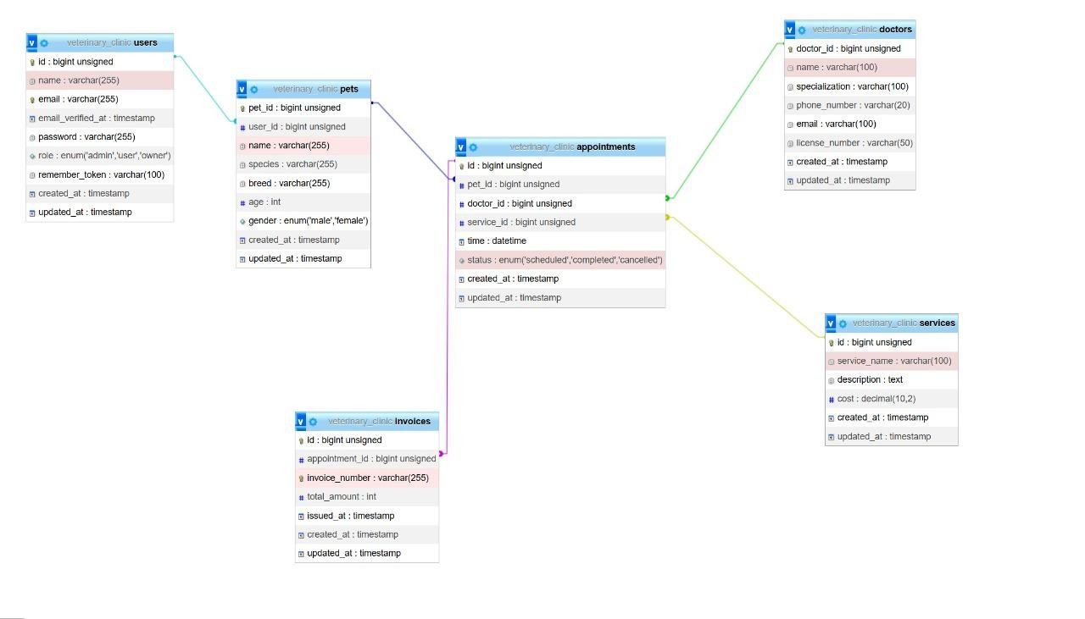

Overview 1. Entity Relational Diagram of Aespaw Project

The Entity Relationship Diagram (ERD) consists of the following main entities:

* Users: Stores information such as name, email, password, and role.
* Pets: Contains pet details and is associated with the *Users* entity.
* Appointments: Records appointments that link pets, doctors, and services, including the date, time, and status.
* Doctors: Holds information about doctors, including their specialization.
* Services: Lists available services along with their costs and descriptions.
* Invoices: Linked to *Appointments* and records financial details for the services provided.

Each relationship between entities is either *one-to-many* or *many-to-one*, depending on the context. For instance, one user can have many pets, but each pet is associated with only one user.

**B. Documentation :**

**Registration :**

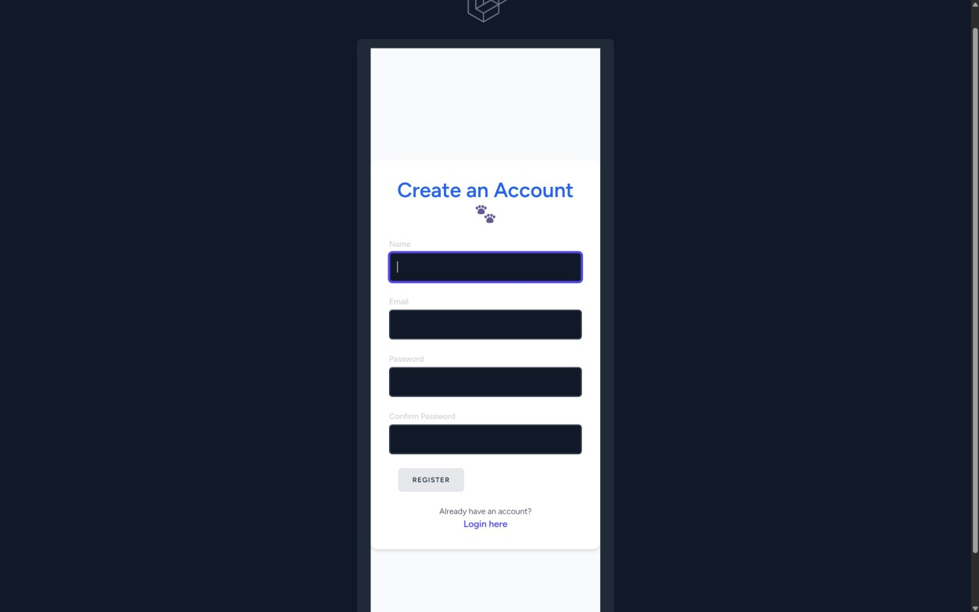

View 1. Registration

**(Registation)**

The Registration page is designed to allow new users to create an account within the system. It is commonly used by pet owners who wish to access features such as managing their pets, appointments, and viewing invoices. The registration form includes input fields for name, email, password, and password confirmation. Laravel's built-in validation ensures that all fields are filled out correctly and that the email provided is not already registered. Upon successful registration, users are redirected either to the dashboard or to the login page, depending on the system's configuration.

For security, all passwords are encrypted using Laravel’s bcrypt hashing algorithm and are never stored in plain text. This feature is implemented using Laravel Breeze, which provides lightweight and simple authentication scaffolding. The form is styled using TailwindCSS to maintain a clean and responsive UI, while Laravel’s validation system handles input checks and error messaging. Overall, this page plays a crucial role in onboarding new users safely and efficiently.

**Login System :**

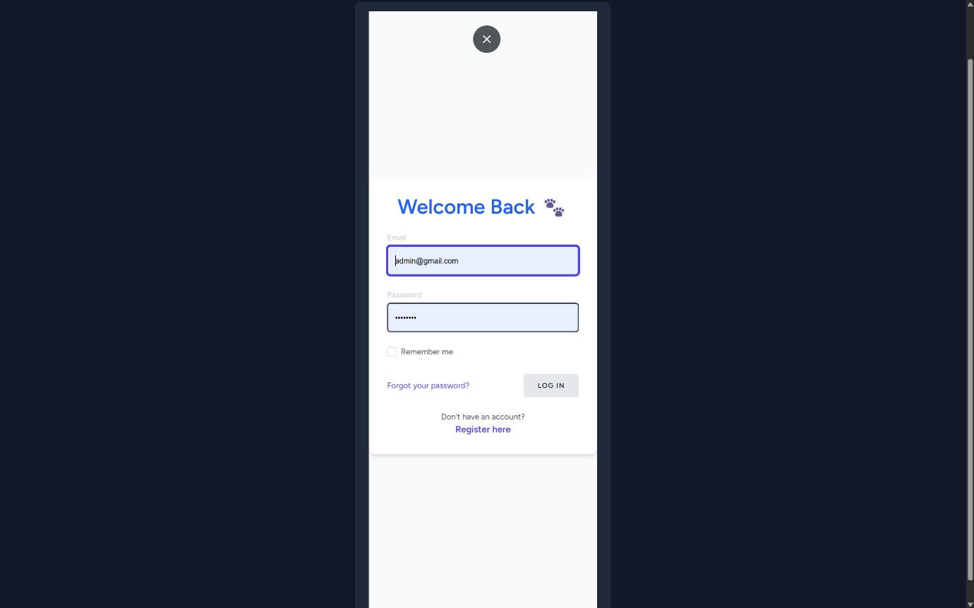

View 2. Login

The Login system allows registered users to securely access their account using their email and password. It acts as the gateway to the system's protected features such as viewing appointments, managing pets, or accessing the admin dashboard (depending on the user's role). The login form is simple and includes fields for email and password, with Laravel handling the authentication process behind the scenes.

Once submitted, the system validates the credentials against the database. If the login is successful, the user is redirected to their respective dashboard. In case of incorrect credentials, a validation error message is displayed without revealing which part (email or password) was invalid—helping prevent brute-force attacks. The authentication flow is powered by Laravel Breeze, which also uses sessionbased authentication for secure access control. TailwindCSS is used to maintain a clean, modern, and responsive interface, consistent with the registration page. This login system is also designed to support role-based redirects in case the project includes multiple types of users like owners, doctors, or admins.

**Navigation :**

**For Users :**



View 3. User Navigation

**Admin :**

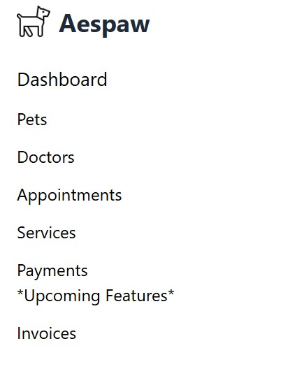

View 4. Admin Navigation

The navigation system in this project is separated into two main types: one for users and one for admins, each tailored to their respective roles and tasks. For regular users (such as pet owners), the navigation includes simple and essential links: Home, Service, Appointment, and About. Each of these pages has its own unique pastel color theme, and the navigation bar adapts its background color accordingly to create a smooth, visually pleasing transition between pages. This dynamic color shift reinforces the cute and clean aesthetic of the platform.

For admin users, the navigation is more system-oriented. It includes access to the Main Dashboard and several links that point to the core CRUD systems: Pets, Doctors, Appointments, Services, Payments, and Invoices. The admin navigation maintains a consistent layout, using icons and clean labeling to make the system intuitive and easy to navigate. While the user navigation focuses on simplicity and visual warmth, the admin panel is designed for efficiency and quick access to management features.

Both types of navigation are built using Blade components and styled with TailwindCSS. On mobile view, the navigation collapses into a responsive menu to ensure accessibility on smaller screens. This role-based navigation ensures each user sees only what they need, improving usability while staying true to the platform’s cute and minimalist design vision.

**User Dashboard (Home) :**

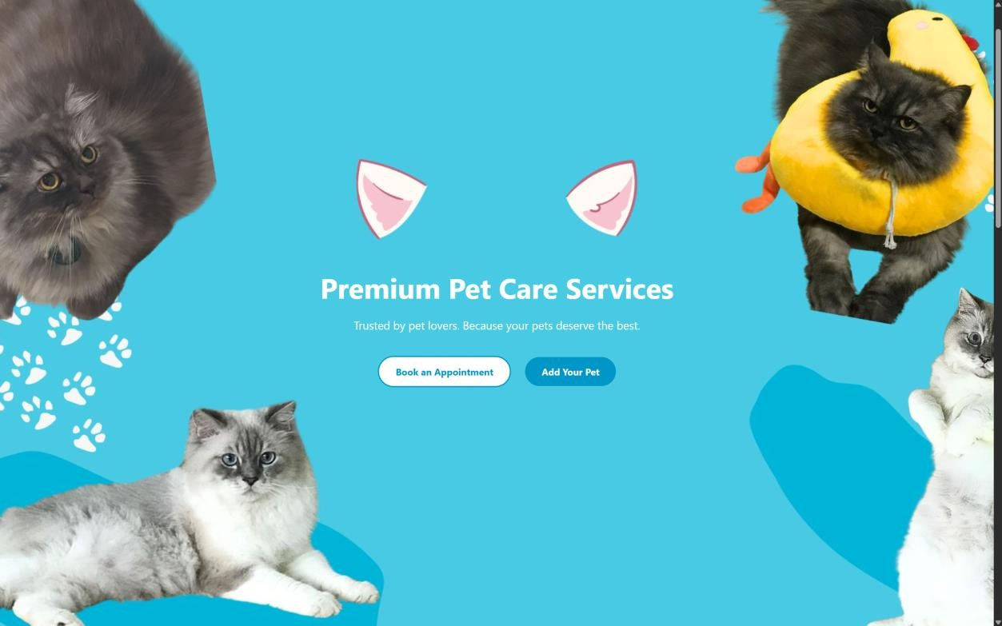

View 5. Home Page

The Home page serves as the main dashboard for regular users and is designed to be both welcoming and functional. Upon logging in, users are greeted with a personalized message that includes their name, giving a friendly and engaging first impression. The design incorporates custom-made cute illustrations and playful animations that align with the platform’s pastel color palette, creating a warm and inviting atmosphere—especially appealing to pet lovers.

This page also acts as a navigation hub. Users are presented with a button to create an appointment, as well as a prominent call-to-action button prompting them to add a pet if it's their first time logging in. This is essential because appointments are linked directly to the user’s registered pets, ensuring personalized scheduling and service management.

In addition, the Home page highlights key promotional content such as the "Our Top Services" section and a "Why Choose Us?" panel, which are aimed at introducing users to the platform’s most popular and trusted offerings. The layout is responsive and interactive, maintaining the cute, clean aesthetic across all screen sizes. This home dashboard is not only functional but also emotionally engaging, reinforcing the platform’s brand identity while guiding users through their first steps.

**Add pet form for user :**

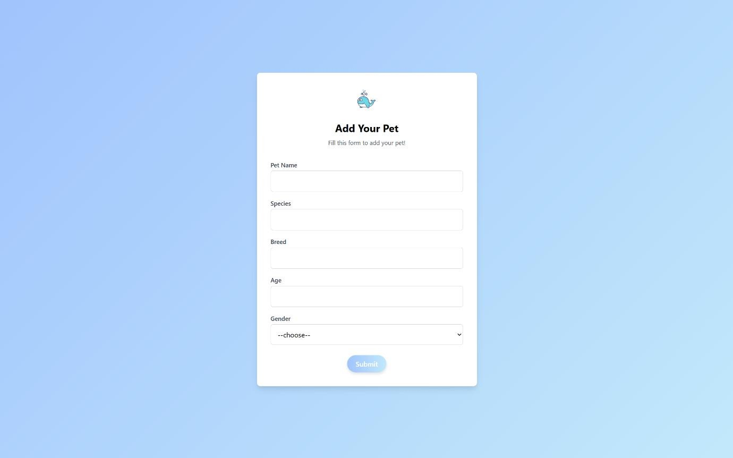

View 6. Users add pet

The **Add Pet** form is designed to allow users to register their pets into the system, ensuring that only the pets owned by the logged-in user are linked to their account. The form includes the following fields for the user to fill out: **Pet Name**, **Species**, **Breed**, **Age**, and **Gender**. These fields help personalize the user’s experience and ensure that only relevant pets appear in the appointment system.

Once the user submits the form, a notification appears confirming that the pet has been successfully added. The user is then redirected back to the **Home** page, where they will see a friendly confirmation message, and the form fields will be reset for ease of use if they need to add another pet. The form design uses a soft **pastel blue** color, matching the aesthetic of the Home page, creating a cohesive and inviting experience.

Although photo upload functionality is not yet included, there are plans to add it in the future, allowing users to upload a photo of their pet for further personalization. This simple yet effective form enhances the user experience by guiding them through the process of adding their pet in a visually appealing, seamless way.

**Service Page :**

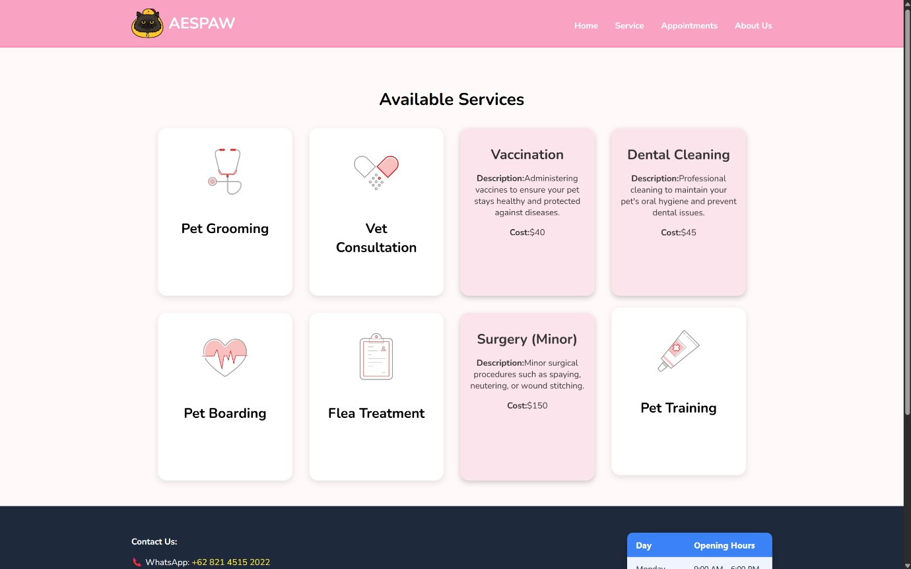

View 7. Service Page

The Service page showcases a list of available services for users, each designed to cater to the needs of their pets. Currently, the page offers 8 services: Pet Grooming, Vet Consultation, Vaccination, Dental Cleaning, Pet Boarding, Flea Treatment, Minor Surgery, and Pet Training. Each service is displayed as a card with the service name and a visually appealing design, using animations like card flips to make the interface more interactive and engaging.

When a user clicks on a service card, the card flips to reveal more detailed information, including a description of the service and its price in USD. This effect is designed to enhance the user experience, providing clear and concise information while maintaining a playful and dynamic feel to the page. As the platform grows, additional services will be added, continuing to provide pet owners with a variety of options to care for their pets.

The use of animated cards and smooth transitions ensures that the page remains visually interesting, while also making it easy for users to explore the available services. This interactive element, paired with clean design and concise service details, helps users quickly find the service they need while keeping the page aligned with the cute and modern aesthetic of the site.

**Appointment Form :**

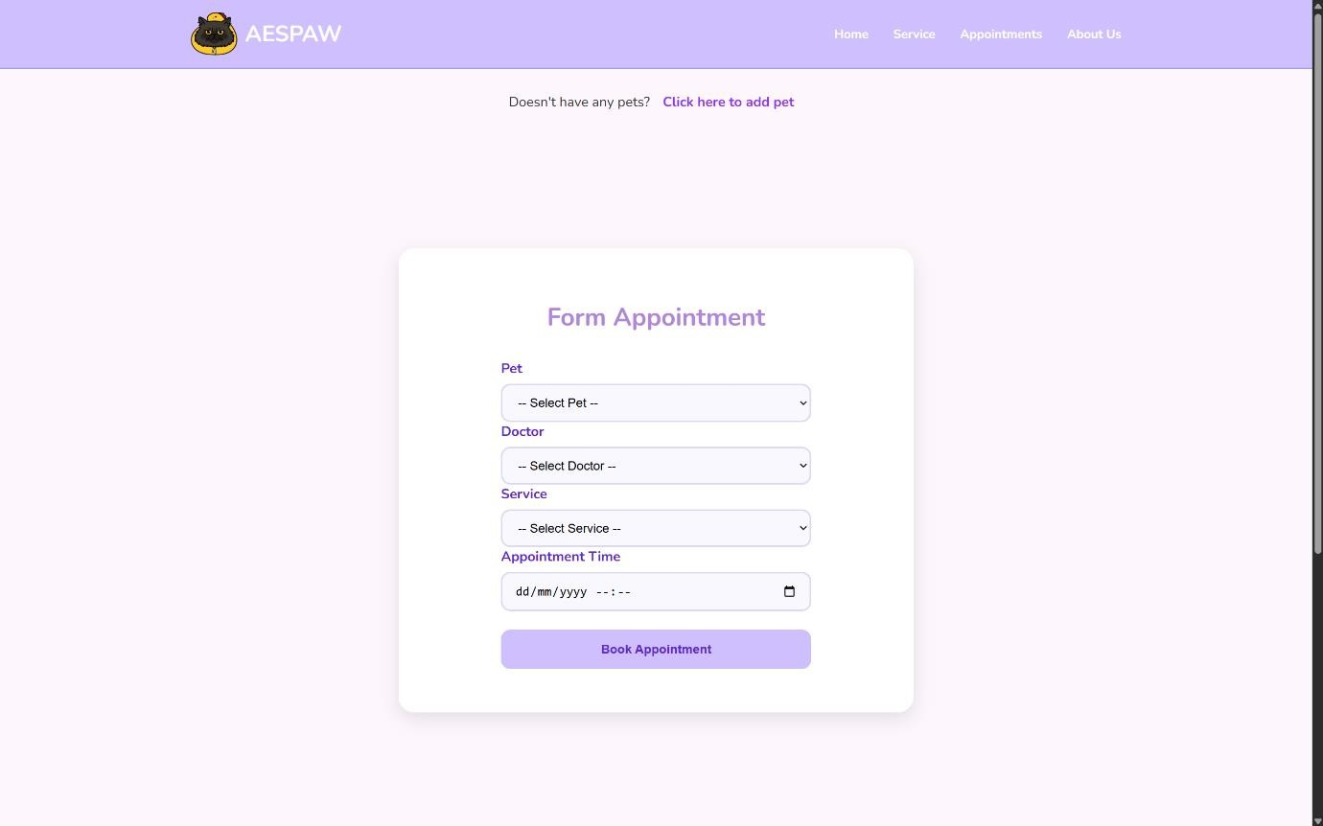

View 8. Appointment Form

The **Appointment Form** allows users to book appointments for their pets with the available doctors. The form is designed to be intuitive and user-friendly, guiding users through each step to ensure they provide all necessary information for a successful appointment.

First, users are required to **select a pet** from their registered pets. If they don’t have a pet registered yet, a prominent button directs them to the **Add Pet** page so they can quickly register their pet before proceeding with the appointment.

Next, the user must **select a doctor** from the available list of doctors. Currently, there are three doctors available, and users can view detailed information about each doctor on the **About Us** page to make an informed decision.

After selecting a doctor, users must choose the **service** they wish to book from a list of available options. The list of services can be viewed in detail on the **Service Page**, allowing users to understand what each service entails before making a selection.

Finally, users will select an **appointment time** from an available schedule. The form includes a validation to ensure that users cannot select a date or time in the past, ensuring that all appointments are scheduled for future dates only.

Once the form is completed, the user will be able to submit the appointment request. A confirmation message will be displayed, and the user will be redirected back to the **Home** page, ensuring a smooth and seamless experience.

**Invoice :**

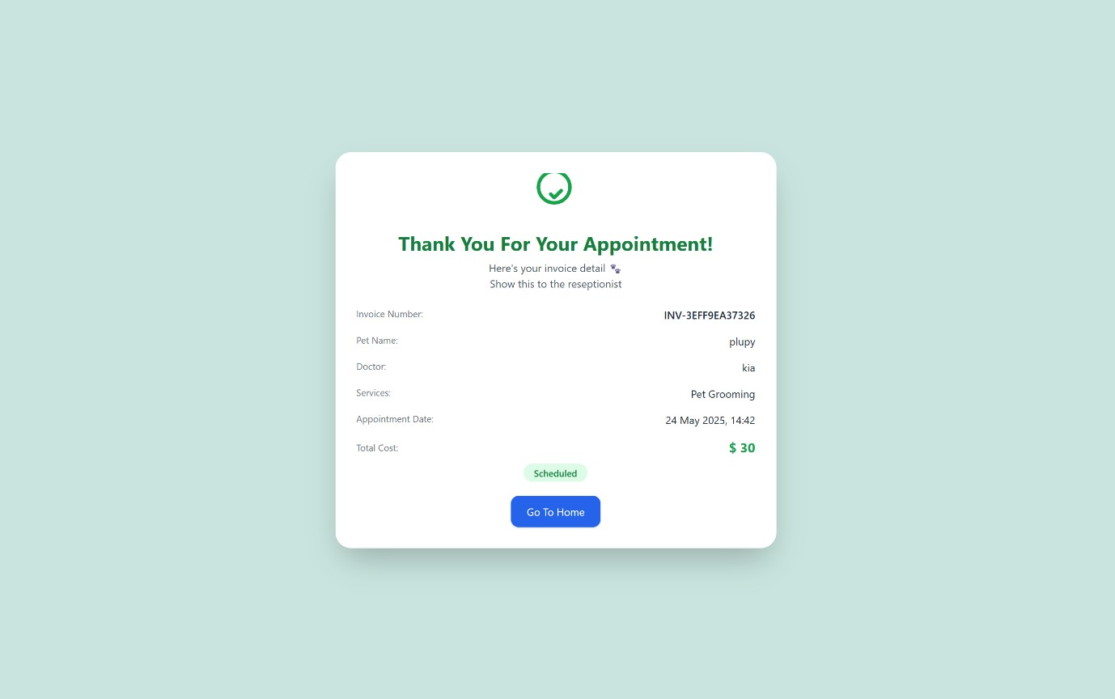

View 9. Invoice View

The **Invoice Page** displays the details of appointments that users have made. It includes the **invoice number**, which can be shared with the admin or receptionist for reference. Additionally, the page shows the **owner's name**, the **pet** being registered, the **selected service**, the **doctor** chosen, the **appointment date**, and the **total price**.

The invoice also includes a status indicating that the appointment has been scheduled, providing a clear confirmation to the user. At the bottom of the page, there is a button that allows the user to easily return to the **Home** page.

This simple yet informative layout ensures users have a complete view of their appointment details in one place, helping them keep track of their bookings.

**About us Page :**

**Welcome & About Section**

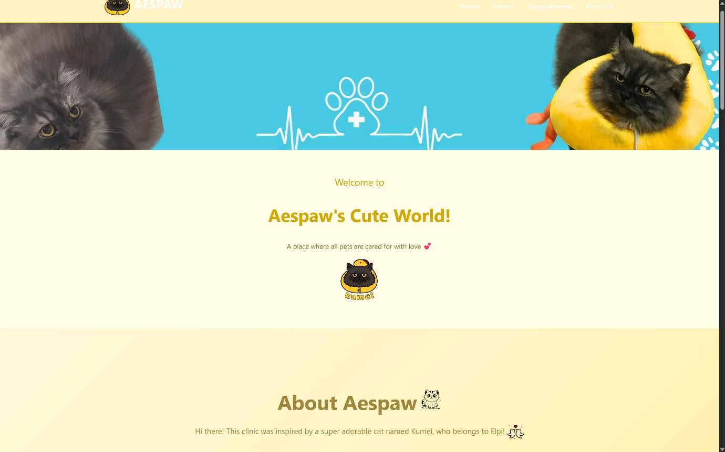

View 10. About Us Page ( Welcome Section )

**Our Inspiration fun fact (Kumel) :**

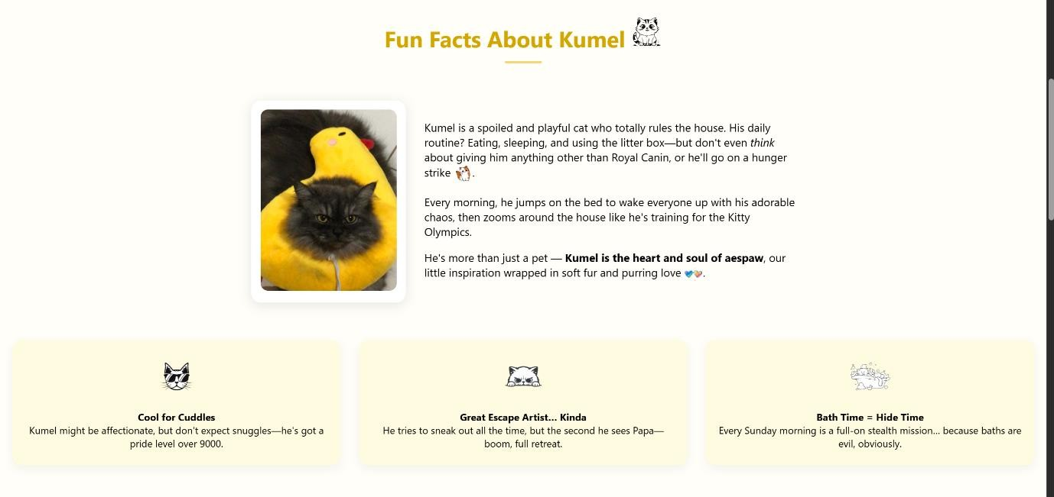

View 11. About Us pages ( Fun Facts Sections )

**Doctors Avaiable :**

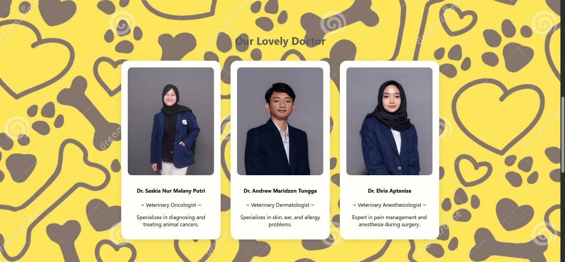

View 12. About Us Pages ( Doctors Sections )

**FAQ :**

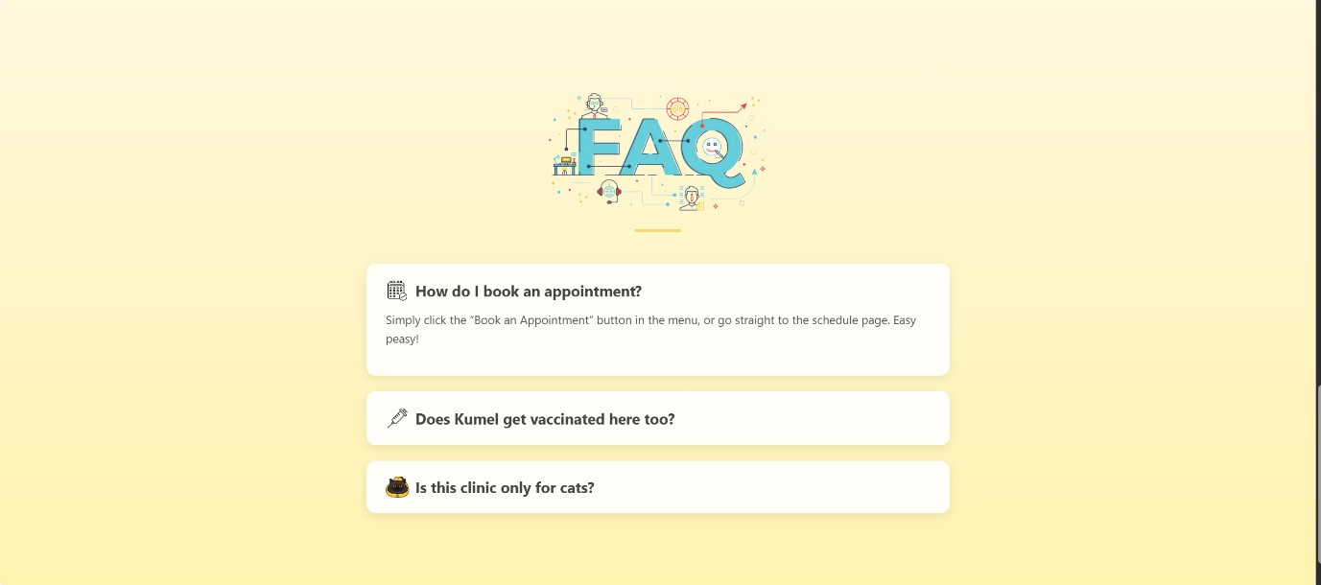

View 13. About Us Pages ( Frequently Asked Question )

**Welcome and About Section :**

The Welcome section provides a warm introduction to the website, setting the tone with a friendly greeting. This section also includes a brief explanation of the clinic's mission, values, and commitment to providing quality care for pets. It's designed to connect with users emotionally and give them confidence in the services offered.

**Kumel Fun Fact :**

In the Kumel Fun Fact section, we share a quirky and cute story about Kumel, the pet that inspired the clinic's name. This section helps personalize the experience, bringing a sense of fun and warmth to the page, while creating a bond between users and the brand.

**Doctors Available :**

The Doctors Available section introduces the medical team, listing the doctors available for appointments. Each doctor has their own profile with information about their specialization, experience, and friendly image. Users can click on each doctor’s profile for more details and decide who best suits their pet’s needs.

**FAQ :**

The FAQ section answers common questions users may have about services, appointments, payments, and general care tips. It helps users navigate the platform easily by providing quick answers to frequently asked questions, improving their overall experience and understanding of the service.

**Footer :**

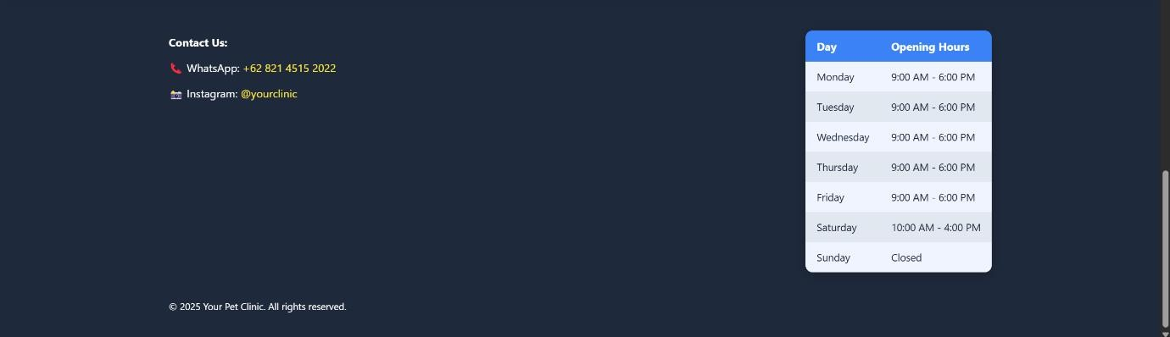

View 14. Footer Sections of All Pages

The Footer is kept simple and clean, displaying essential information such as the clinic’s opening days and hours, a “Contact Us” section, and quick links to WhatsApp and Instagram for direct communication and social engagement. While the design is currently minimal.

**Admin Dashboard :**

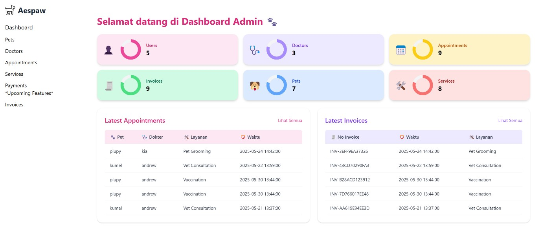

View 15. Admin Dashboard ( Main Dashboard )

The **Admin Dashboard** provides a visual overview of the system using interactive charts powered by JavaScript to display key data counts such as users, pets, appointments, and services. Below the charts, the dashboard shows the **latest 5 appointments** and **latest 5 invoices**, helping admins stay updated with recent activities at a glance. The layout follows the site's pastel and cute theme, keeping it both functional and visually appealing.

**CRUD of table :**

**Read**

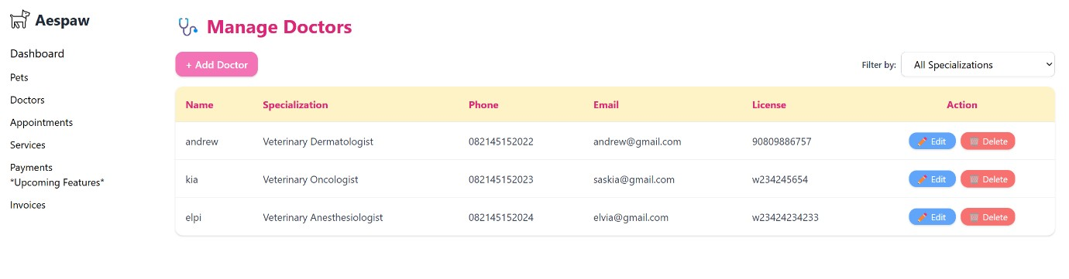

View 16. CRUD Admin ( Read )

**Create :**

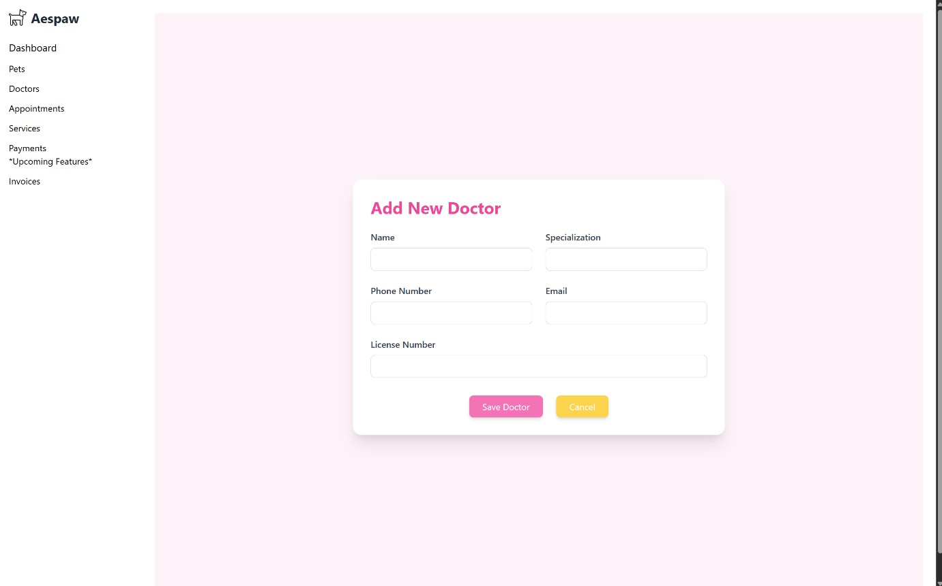

View 17. CRUD Admin ( Create )

**Update :**

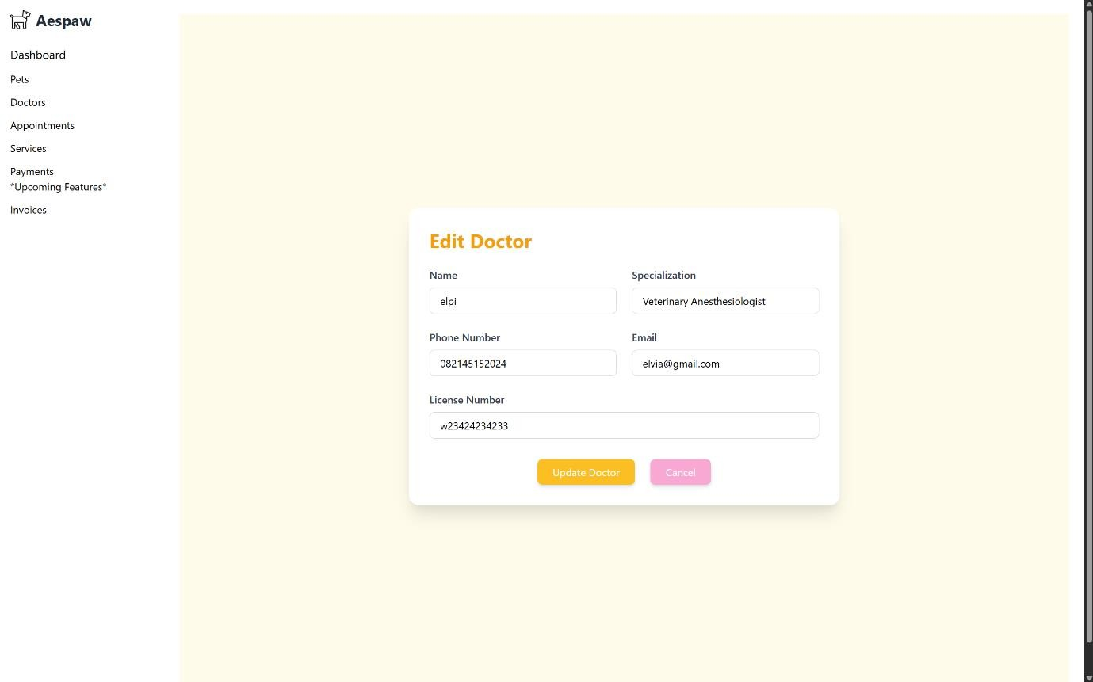

View 18. CRUD Admin ( Update )

**Delete :**

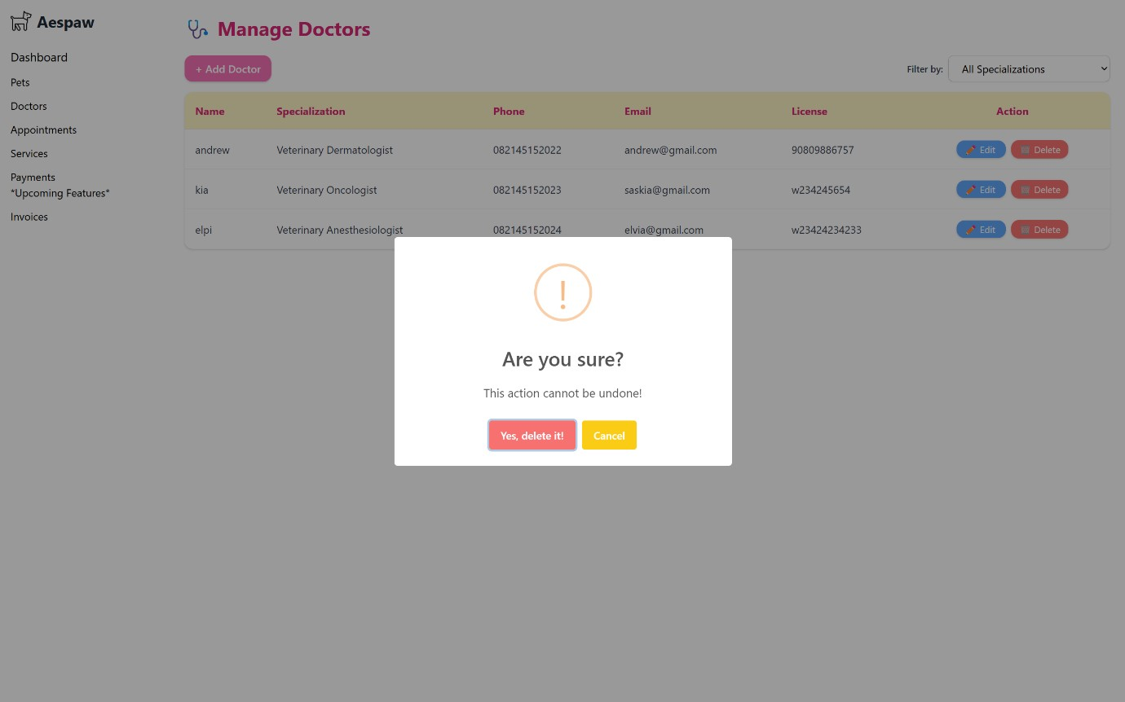

View 19. CRUD Admin ( Delete )

The admin panel includes **6 CRUD tables**: Pets, Doctors, Appointments, Services, Invoices, and Payments. All tables follow a consistent, pastel-themed design with a cute and clean layout. Each table supports **Read**, **Create**, **Update**, and **Delete** functionalities.

For **reading data**, each page displays up to **10 entries**, with pagination controls for navigating through additional records. A **filter/search** feature helps admins quickly find specific data. The **Create** and **Update** pages use uniform forms that match the site's aesthetic. For **deletion**, an animated confirmation alert is shown to ensure admin confirmation before removing any data.

**C.1 BUSINESS FUNCTIONS**

The Aespaw Petshop system supports the following core business functions:

* “Register Account”

Create a new user account by entering name, email, and password. By default, users are registered with the "owner" role.

* “Log In / Log Out”

Access their account securely and log out when finished using the system.

* “Edit Profile”

Update personal details including name, email, and password.

* “Add Pet”

Register a new pet to the system by filling in pet details such as name, species, breed, age, and gender.

* “View My Pets”

See a list of all their registered pets.

* “View Services”

Browse a list of available veterinary services, including service name, description, and cost in USD.

* “View Available Doctors”

Access the list of veterinarians and their specializations on the “About Us” page.

* “Make Appointment”

Create an appointment by selecting one of their pets, a doctor, a service, and a desired date/time.

* “View Appointments”

Review their appointment history and status (e.g. scheduled, completed, cancelled).

* “View Invoice”

After booking an appointment, view the automatically generated invoice including invoice number, amount, and appointment reference.

* “Show Invoice at Clinic”

Present the invoice number or a screenshot at the clinic reception as proof of booking.

**C.2 DATA REQUIREMENTS**

* User Account Information (name, email, password, and role [owner or admin])
* Pet Information (pet name, species, breed, gender, and owner/user ID)
* Service Information (service name, service description, and price in USD)
* Doctor Information (doctor name, specialty, availability status)
* Appointment Information (selected pet, selected doctor, selected service, appointment date, appointment status, and appointment timestamp)
* Invoice Information (invoice number, related appointment, total cost, creation date)
* Admin Information (admin name, email, and password)
* About Us Page Data (list of available doctors with their name and specialty)
* User Activity Tracking (timestamp of booking, list of user-created pets and appointments) • Authentication Logs (basic timestamp of user login and role verification)

**C.3 BUSINESS RULES**

1. User Registration & Roles
   * Users must be able to create an account with a valid name, email, and password.
   * Each user must be assigned one role: admin, user, or owner.
   * Email addresses must be unique and verified before access is granted.
2. Authentication & Security • Users must be able to log in using their email and password.
   * Users must be able to reset or change their password by confirming the current one.
   * User sessions should be securely managed (e.g., via tokens).
3. User Profile Management
   * Users can update their personal information including name, email, and password.
   * Only the account owner or an admin can update a user's profile.
4. Pet Management • Each pet must be linked to a specific owner (user).
   * Owners can add, view, update, and delete their pets' data (name, species, breed, age, gender).
   * A pet must belong to one and only one user.
5. Doctor Management • Only admins can add, update, or remove doctors from the system.
   * Each doctor profile includes name, specialization, phone, email, and license number.
   * Each doctor must have a unique license number.
6. Service Management
   * Admins can create and manage veterinary services with details: name, description, and cost.
   * Each appointment must be linked to one existing service.
7. Appointment Scheduling
   * Owners can schedule appointments for their pets by selecting a doctor, a service, and a date/time.
   * An appointment must be linked to one pet, one doctor, and one service.
   * Appointments must have a status of scheduled, completed, or cancelled.
   * The system must prevent overlapping appointments for the same doctor.
8. Appointment Access & Control
   * Owners can only view and manage appointments for their own pets.
   * Doctors can view appointments assigned to them.
   * Admins can view and manage all appointments in the system.
9. Invoice Generation
   * An invoice must be generated once an appointment is marked as completed.
   * Each invoice must be linked to exactly one appointment.
   * An invoice includes a unique invoice number, total amount, and issue date.
   * Only one invoice can be created per completed appointment.
10. Data Integrity
    * Deleting a user must either cascade to delete their pets (if allowed) or be restricted.
    * Services, doctors, or users involved in appointments or invoices cannot be deleted without preserving relational consistency.